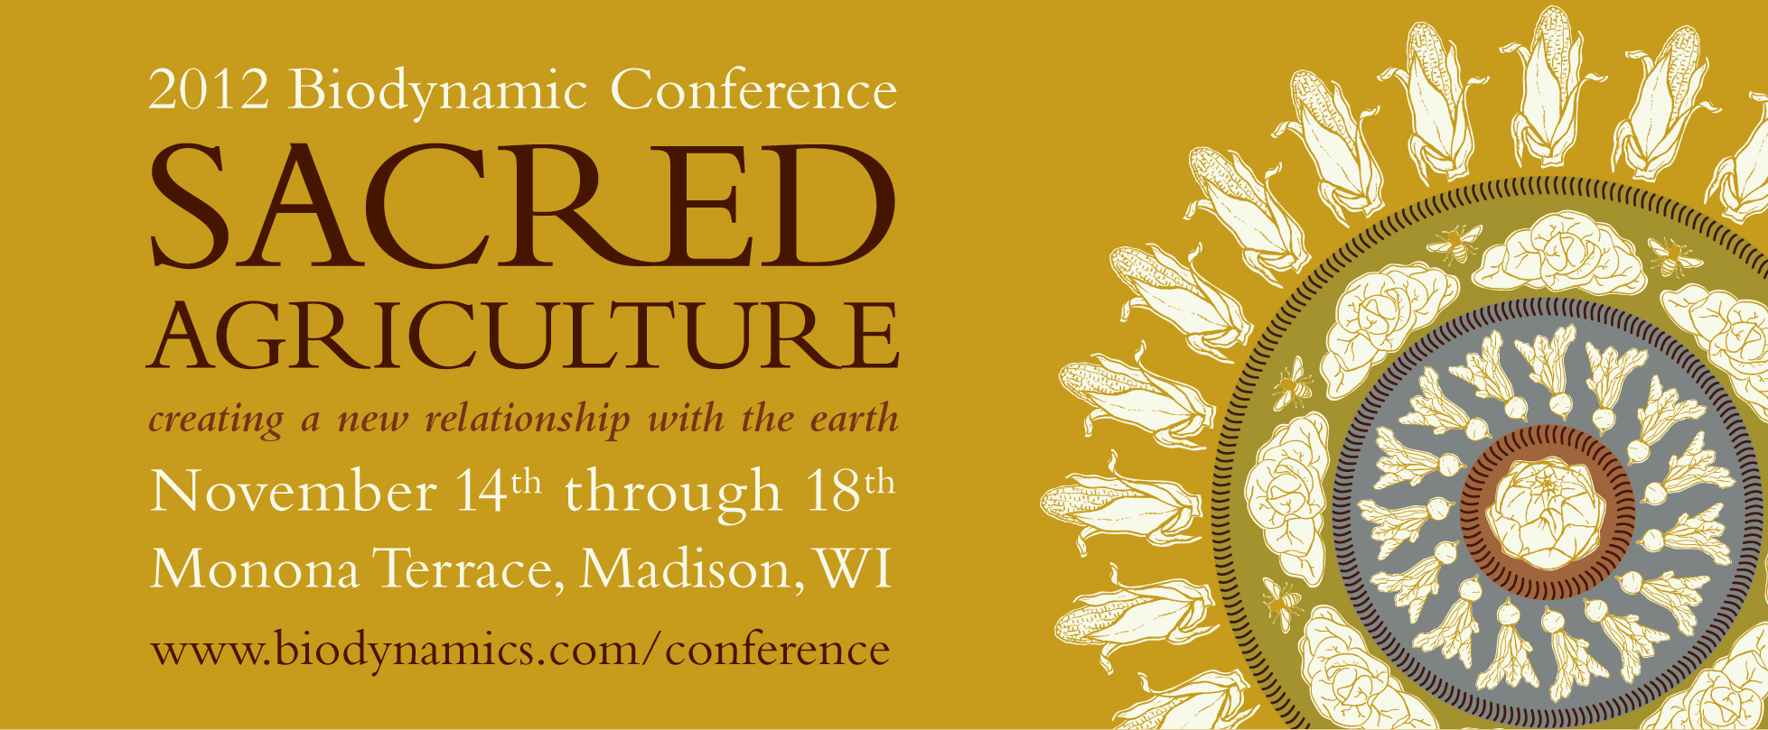

Sample Text for 2012 Biodynamic Conference Announcements

Calendar, Website, or Newsletter Listing

Join the Biodynamic Association on November 14-18, 2012, at the beautiful Monona Terrace Community and Convention Center in Madison, WI, for an extraordinary event — the 2012 North American Biodynamic Conference. This biennial conference is the foremost event for biodynamic education, networking, and community building on the continent, bringing together hundreds of farmers, gardeners, educators, activists, and interested newcomers for five days of inspiring keynotes, informative workshops, networking, exhibits, film screenings, art, and organic and biodynamic foods.

This year’s theme, “Sacred Agriculture: Creating a New Relationship with the Earth,” will focus on how we can build a sacred relationship to the earth through farming, gardening, and transformational work in our communities.

www.biodynamics.com/conference

Social Media Posts

Join us at the 2012 Biodynamic Conference, Sacred Agriculture, Nov 14-18 in Madison #bdaconf2012 www.biodynamics.com/conference

Sacred Agriculture: Creating a New Relationship with the Earth, Nov 14-18 in Madison #bdaconf2012 www.biodynamics.com/conference

Conference Graphics: Images are available for download at www.biodynamics.com/conference/media. For images posted on websites or social media, please link to www.biodynamics.com/conference.

More Information: Contact Rebecca Briggs at rebecca@biodynamics.com for more specific language on workshops, presenters, special events, or other requests.

