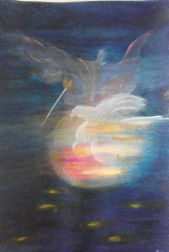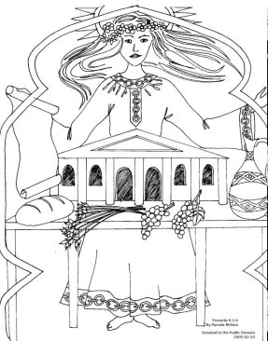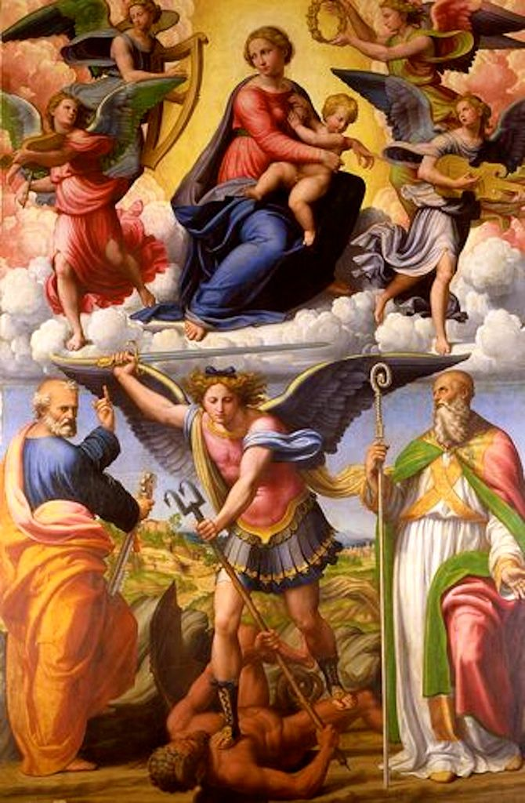
The CRC Michaelmas Festival: ‘Courage Born of Wisdom’ FREE – Zoom details to follow
Wednesday 23 September 2020 – The Autumnal Equinox – 7:15 pm CDT – 8:30 pm
1st -A tale from ancient Chaldea where sophEA gives birth to Marduk, precursor to Michael.
Then “Wisdom Built herself a house (Proverbs 24: 1-9)”…7 members from various sections of the Anthroposophical Society will stand as Wisdom’s 7 Pillars to share how Courage was Born from Wisdom for them, leading to their work in the world.
Medical Section –Drs. Molly & Quentin McMullen
Social Science Section – Doug Wylie
Youth – Stephan Ambrose
BD – Rand Carter
Pedagogical –Michael Holdrege
3-folding - Dorothy Hinkle-Uhlig
Eurythmy – Barbara Richardson
Closing: The connection between Michael, The Christos & Anthroposophia!
CRC: Marianne Fiber, Alberto Loya, Hazel Archer-Ginsberg, Lisa Dalton

