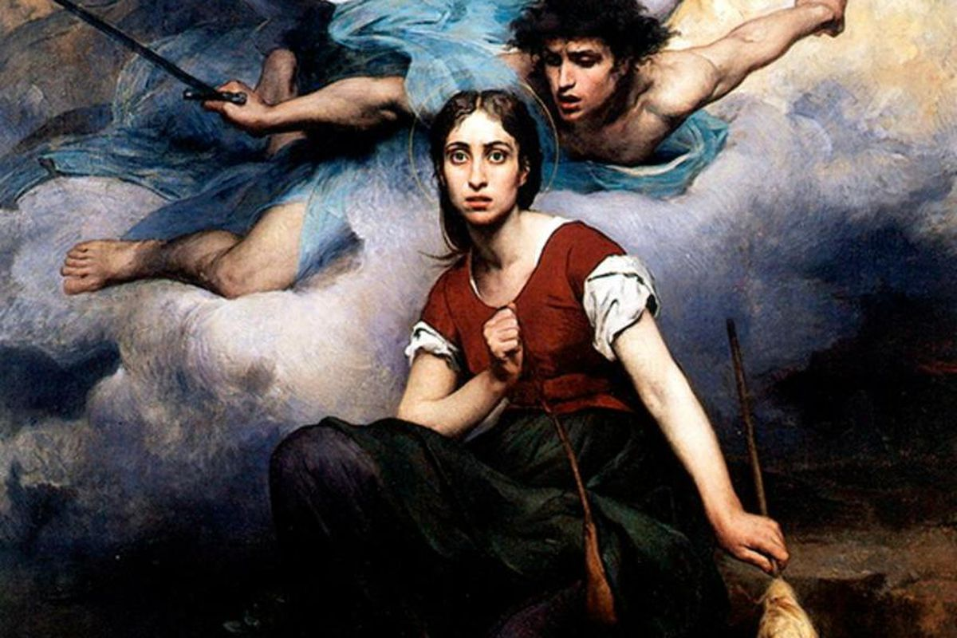

Our annual Michaelmas Festival & Youth Gathering
IN PERSON at Elderberries 4251 N. Lincoln Ave. Chicago & ONLINE

Sat. & Sun. 26-27 Sept. 2020 – 2 pm – 4 pm CDT

Joan d’Arc – PURIFYING FIRE: The Power Behind the Will

with special guests: Angela Foster from Atlanta; & Mary Spalding
Including a performance of ‘The Passage” by Lucian Dante Lazar
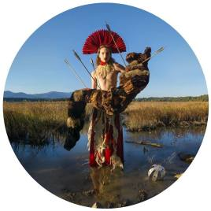

Sponsored by: The Rudolf Steiner Branch
For more info. & ZOOM details contact Festivals coordinator Hazel@ReverseRitual.com

