Earth, Water, Air, Fire:
Exploring the Spiritual Scientific Foundations of Biodynamic Agriculture

with Robert Karp

Friday, April 20 and Saturday, April 21
Santa Fe Waldorf High School

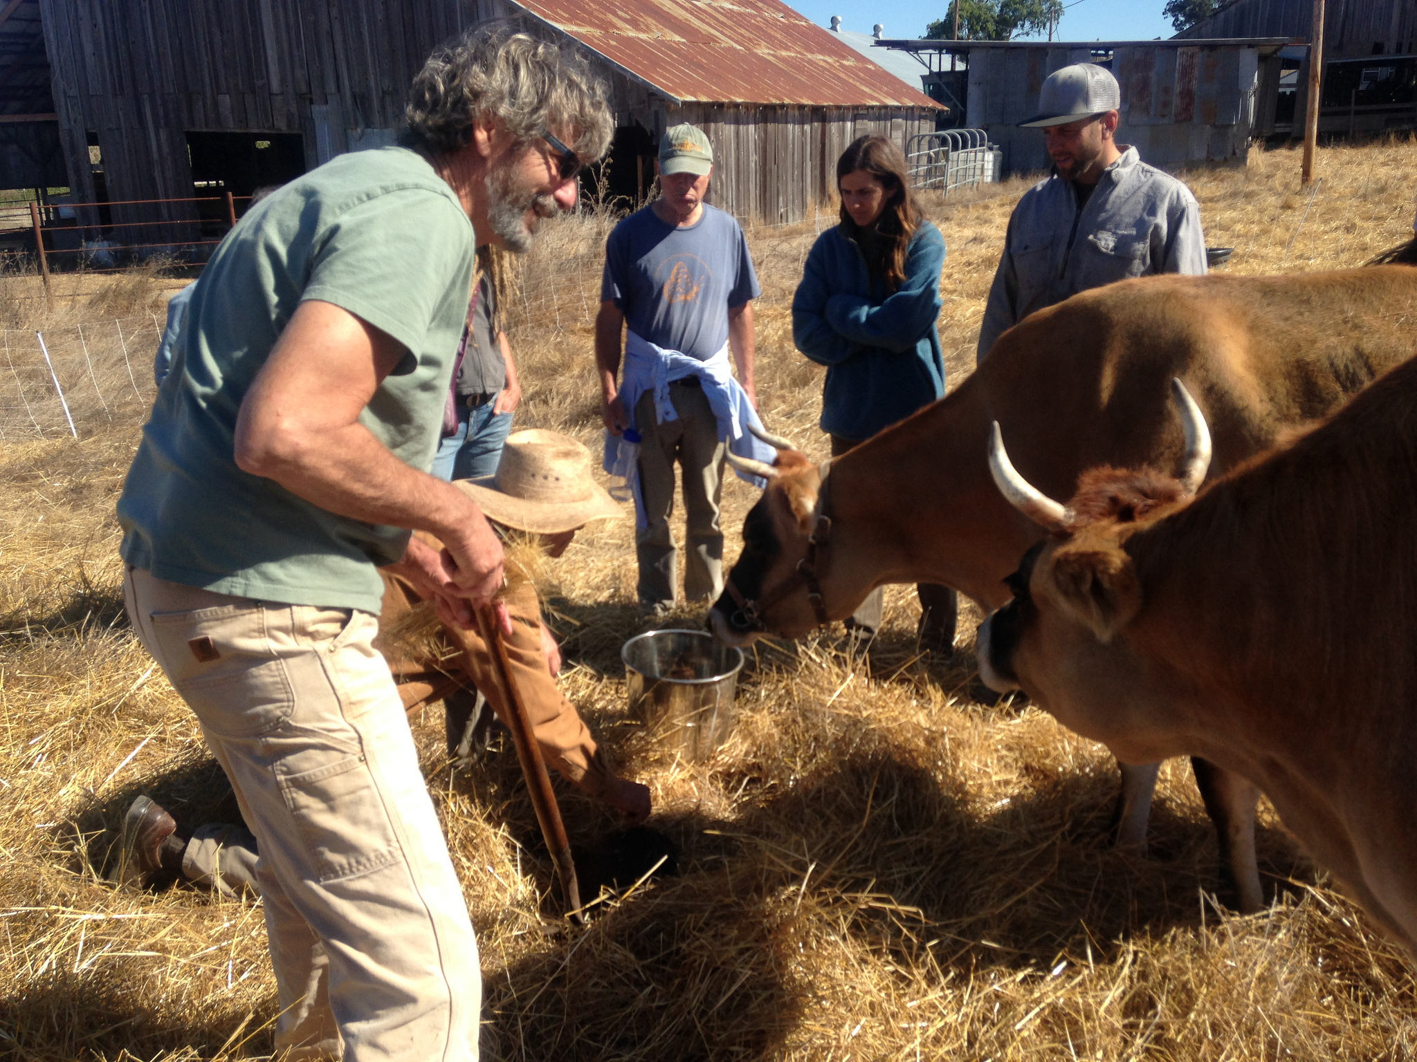
The SFWS Foundations Group is pleased to host Robert Karp for a weekend workshop titled Earth, Water, Air, Fire: Exploring the Spiritual Scientific Foundations of Biodynamic Agriculture. Both the Friday evening lecture and the Saturday workshop are open to the public.

Description of the Course Content:
What if the whole earth, like a human being, is a self-regulating organism with qualities of body, soul and spirit? What might this mean for sustainable agriculture, for environmental activism and for the education of children? On Friday night we will explore a new way of understanding soil, plants, animals, humans, the seasons, the nature spirits and much else besides, through the lens of spiritual science. This will lay a foundation for understanding the principles and practices of biodynamic farming and gardening as well as Waldorf education. On Saturday we will practice a number of social-ecological-artistic exercises designed to help us enter more deeply into the body, soul and spirit of the living earth. This work will culminate in a simple, celebratory offering of love and healing for the earth.

Friday, April 20, 7:00 - 8:30 pm: Introductory Lecture, $10-30, sliding scale
Saturday, April 21 9:00 am – 3:00 pm: Workshop $180
at the Santa Fe Waldorf High School

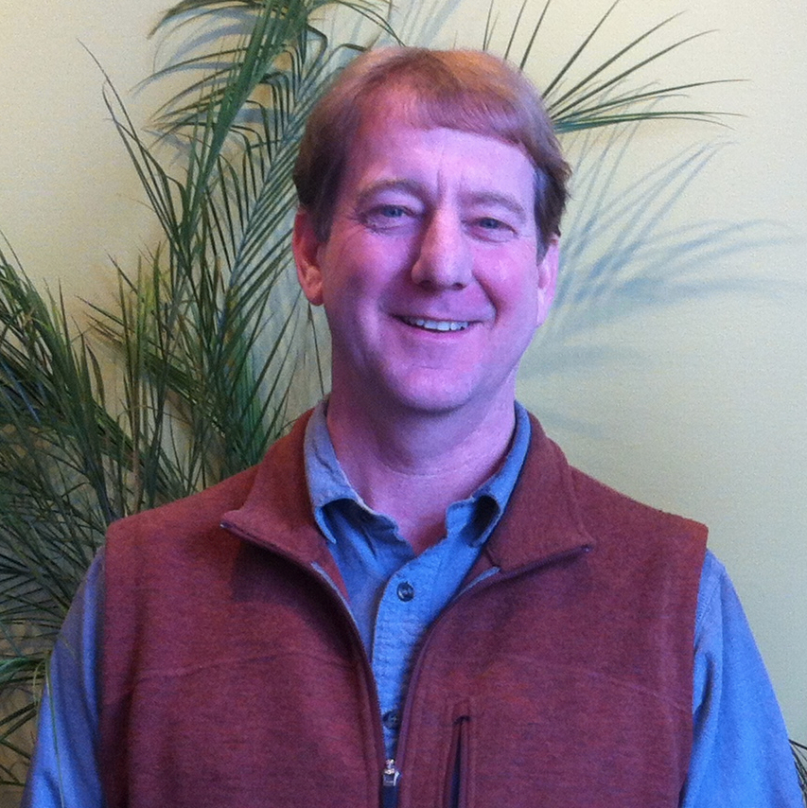
Robert Karp is a writer, educator, consultant and social entrepreneur informed by the insights of the philosopher and social activist Rudolf Steiner. Robert is the former Executive Director of the Biodynamic Association and of Practical Farmers of Iowa and is the founder and director of New Spirit Farmland Partnerships and the Monarch Farms Project which helps organic and other conservation minded farmers secure long-term access to farmland by facilitating partnerships with social impact investors. Robert lives in Milwaukee, Wisconsin. You can learn more about Robert’s work and find more of his writings on his website at www.robertkarp.net.

